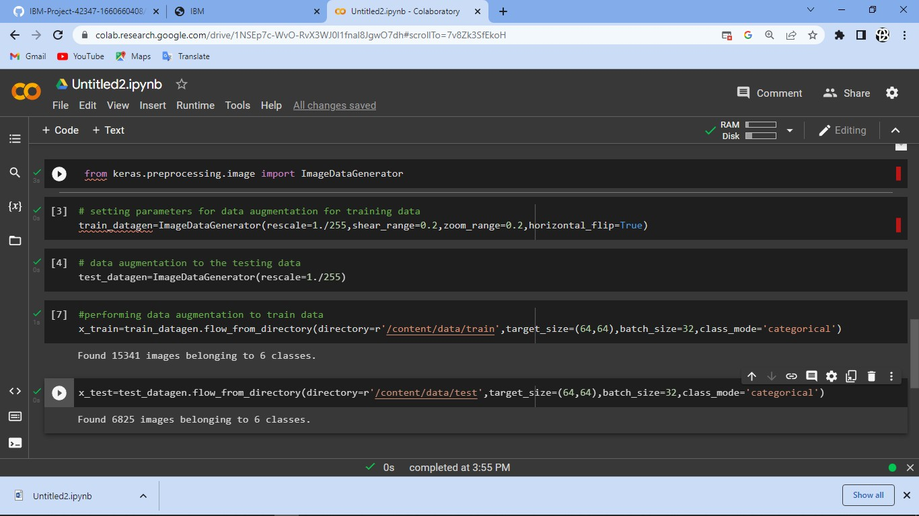TEAM ID:PNT2022TMID30495

TITLE:Classification of Arrythmia by using the deep learning 2-D ECG spectral image representation

DATE:19 November 2022